Devops tools:

1. Version control: Git
2. Build tool :Maven
3. Continuous integration tool : Jenkins
4. Configuration management tool :Chef
5. Configuration management tool :Puppet

Comparison between devops and agile:

Difference between Agile and DevOps. The key difference between Agile versus DevOps is that Agile is a philosophy about how to develop and deliver software, while DevOps describes how to continuously deploy code through the use of modern tools and automated processes.

Vmodel : The V-model is a type of SDLC model where process executes in a sequential manner in V-shape. It is also known as Verification and Validation model. It is based on the association of a testing phase for each corresponding development stage. Development of each step directly associated with the testing phase. 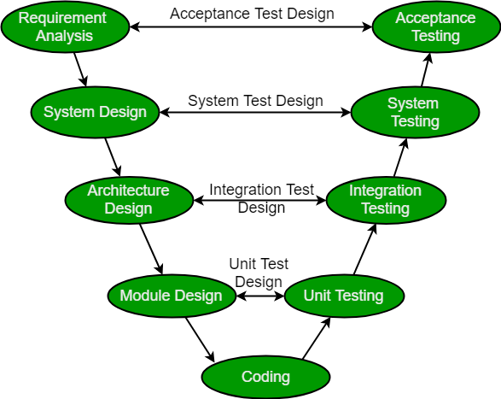

# Design pattern: in software engineering

, a software design pattern is a general, solution to a commonly occurring problem within a given context in software design It is not a finished design that can be transformed directly into source or machine code. Rather, it is a description or template for how to solve a problem that can be used in many different situations. Design patterns are formalized best practices that the programmer can use to solve common problems when designing an application or system.